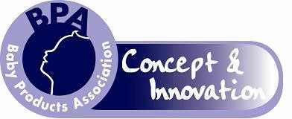

Application Form 2016/2017

Name:

Address:

Post Code:

Tel no:

Email:

If you are a student of higher education, please state the University/College you are attending, which course you are undertaking and which year the course will be completed.

Name:

Address:

Post Code:

Course Title:

Year of course completion:

Please return this entry form to the BPA by 12 noon, 4th January 2017.

Award Choice

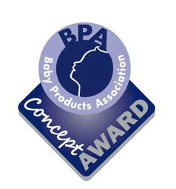
My product is in its early phase of development and I wish to enter it within BPA Concept

Please tick here

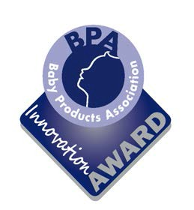

My product is in its final phase of development and I wish to enter it within BPA Innovation

Intellectual Property
Please tick here

The BPA strongly advises entrants to safeguard and secure the Intellectual Property rights and design rights of their products. Although the BPA employees and members of the judging panel sign confidentiality agreements, if you succeed as a finalist, you will be asked to showcase your product to the industry and therefore your product will be in the public domain.
A signed confidentiality agreement was sent with this entry form. Please sign and return this with your application. All entries will be treated in the strictest confidence, and will be shown only to the judging panel.
For further information and advice in the first instance, please contact the UK Intellectual Property Office.

UK Intellectual Property Office, Concept House, Cardiff Road, Newport NP10 8QQ Website: www.ipo.gov.uk
Email: enquiries@ipo.gov.uk Telephone: 0845 9500 505 or 00 44 1633 813930

WITHIN THE SPACE PROVIDED BELOW AND ON THE FINAL PAGE, please outline the nature of the product you are entering and include pictures and/or drawings.
After the closing date, a shortlist of candidates will be selected by the judges. These entrants will then be asked to present to the judging panel, providing more comprehensive information about their product. A presentation using Microsoft PowerPoint will be possible at this stage, if desired. This will take place in late January/early February 2017 (date to be confirmed) and from here, the finalists will be chosen. The finalists will be asked to exhibit their product at one of the industry’s premier trade events with which the BPA partner; Harrogate International Nursery Fair which runs from 28th to 30th March 2017. This is an incredible opportunity for you to showcase your product design and the experience alone is considered a worthy prize. Please ensure you are available to attend this 3 day event as this is a necessary requirement for entry to the award programme. The winner for each category will be announced at the Party and Awards Night during the evening of 28th March when the presentations will take place.
Please address any queries about the competition to Julie James at the Baby Products Association: Tel: 0845 456 9570: Email: julie@b-p-a.org.
For more information about the trade event, visit www.nurseryfair.com

Product Information
Please outline the nature of the product you are designing, its purpose and the age range for which it is intended. Please refer to the guidance notes which were sent to you with this entry form. We recognise that your original concept may change as you develop your ideas. All entries will be treated in the strictest confidence, and will be shown only to the judging panel.

Continue on a separate sheet if necessary or preferred

Signed

Date _

Please submit your entry by 12 noon on 4th January 2017 to:

Julie James, BPA, Grove House, 33 Ashgrove, Steeple Claydon, Bucks MK18 2LW

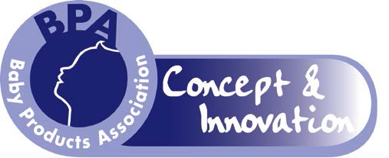

Guidance notes for applicants
About the BPA
The Baby Products Association (BPA) was established in 1945, with the objective of promoting the baby and nursery products sector in both the UK and Europe. It is now the voice of the baby and nursery products industry. Today, it plays an active role in the development of product standards and provides an umbrella of support and specialist services to its membership.

What are the BPA Concept & Innovation Awards?
The BPA actively encourages new product development and innovation in its industry and, for a number of years, has championed visions of new design through the BPA Concept Award. The award is presented at one of our partner premier nursery trade events; The Baby Show for Trade in the presence of key members of the industry.
In previous years, we have seen new inventions launched successfully onto the UK market via the BPA Concept Award. The BPA believes it is important that the industry has a vibrant and proactive outlook on innovation and is determined that new ideas continue to come through.
In 2009 the award programme evolved slightly; the core objective has always been to recognise new concepts and now the programme has grown to recognise designs in their infancy and those closer to the finished article. Under the umbrella of BPA Concept & Innovation, we now have two awards; the BPA Concept Award, acknowledging products still in their early visionary phase and BPA Innovation acknowledging products developed to a potential production stage.

What are we looking for?
Products should be within the following scope:

All baby and nursery products, baby related equipment such as prams, pushchairs, buggies, nursery furniture, highchairs, safety related items including barriers, car sets and restraints, clothing, bedding, alarms, gifts for young children and prospective parents, toys, audio and books should be included. Accessories for all the above categories should also be included.
Please note, this award programme only applies to products in development and not articles available for sale as at 28th March 2017.

Applicants are asked to consider the following aspects when considering their application:

- Use of environmentally friendly and sustainable goods
- Safety awareness and reduction of accidents
- Current and future requirements and demands on parents in everyday living The issues you need to think about at this stage are:
- What is the purpose of the product?
- What age and weight range is it suitable for?
- Is it novel? What would be its unique selling point(s)?
- What leads you to believe that the product will sell?
- How much will it cost to make the economic batch quantity and what will be the retail price of the product?
- Is it safe? Which safety standard(s) are relevant to your product and is it likely to meet these standards?
- What information should be included in the instructions for use on the packaging, on the product itself and at the point of sale?

For products where there are no relevant product safety standards applicable, it may be necessary to consult PD CEN/TR 13387:2015 – Child Care & Use Articles – General & Common Safety Guidelines (Parts 1-5).

Interested?
If you would like to enter either of these awards, please complete the attached entry form, clearly stating which award programme you are entering (BPA Concept or BPA Innovation). When submitting your application, please also include engineering drawings and/or photographs or sketches of your product. Applications should be returned no later than 12 noon, 4th January 2017 to:

Julie James, BPA, Grove House, 33 Ashgrove, Steeple Claydon, Buckinghamshire MK18 2LW
A shortlist of candidates will be asked to formally present their products to the judging panel, providing further information about the product and where appropriate, demonstrate a prototype. It will be possible for these selected entrants to use a Powerpoint presentation if desired. From this meeting, the finalists will be chosen.

The Prize
The finalists will be invited to attend Harrogate International Nursery Fair in conjunction with the BPA which runs from 28th – 30th March 2017 as an exhibitor, showcasing their products to the nursery industry. Finalists will be required to provide a prototype or professional graphic drawings for the exhibition stand. The winners of both awards will be announced on the second day of the show.

Services which may be of interest
- Stonebridge Corporate Insurance Solutions – As a privately owned independent insurance intermediary, Stonebridge is able to offer impartial advice and recommend an insurance company to meet the specific needs of your business. They understand the nursery industry and will offer a tailored insurance solution to meet your changing needs and protect your business as it grows.

- GFS – Global Freight Solutions is the UK’s premier parcel carrier management company and has partnerships with the UK’s top carriers providing enhanced delivery service through the use of its technology and customer care team.

- Baby-TV – is a digital information channel delivering information, advice, hints and tips in maternity department waiting rooms nationwide. It is also a commercial medium and many suppliers of baby products advertise and sponsor initiatives to reach their target audience.

- Lupton Fawcett – is a Leeds-based integrated commercial law firm focussed on the legal needs of both businesses and the people that own and run them. It can offer specialist advice on company law, employment issues, agents, regulatory defence, commercial property, intellectual property, dispute resolution, insolvency, franchising and corporate finance.

- AIMS Accountants for Business – the largest independent association of professionally qualified accountants in the UK offering accounts services, payroll, tax / VAT returns, bookkeeping and self-assessment.

- Touchfinder – specialists in bespoke software solutions.

If you would like contact details of any of the above companies, please call the BPA on 0845 456 9570 or email julie@b-p-a.org.

